# User Manual

Hostel Room Allocation System

Ashutosh Rai

205119021

### Login Page

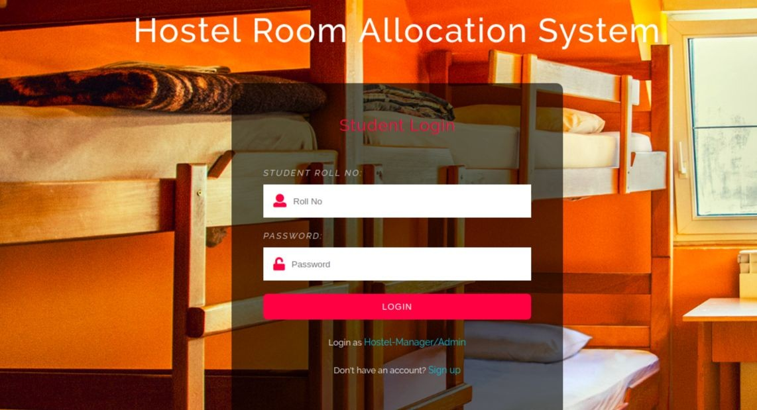

Users who have previously registered for the Hostel Room Allocation System Web Application must login by:

* 1. Entering their Username/Roll No.
  2. Entering their Password.

Selecting Login to advance to the next screen and begin using the application.

### Sign Up Page

Students who have not previously registered for the Hostel Room Allocation System Web Application must select “Register to use the site” to access the “New User Registration” page. There they can enter all the required details and register themselves in the portal.

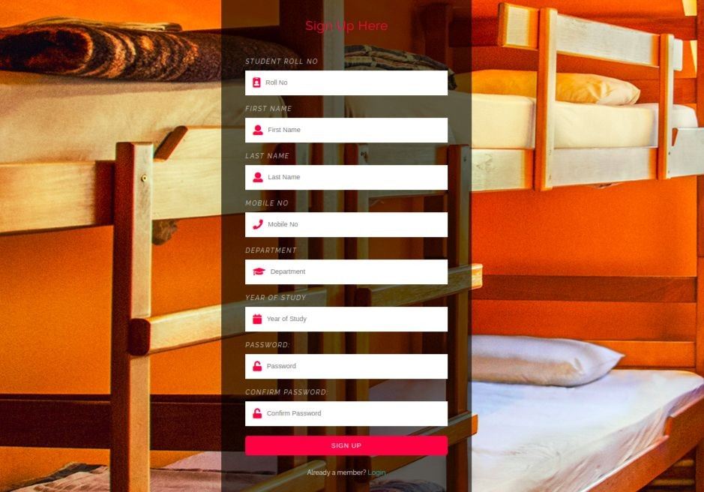

### Home Page

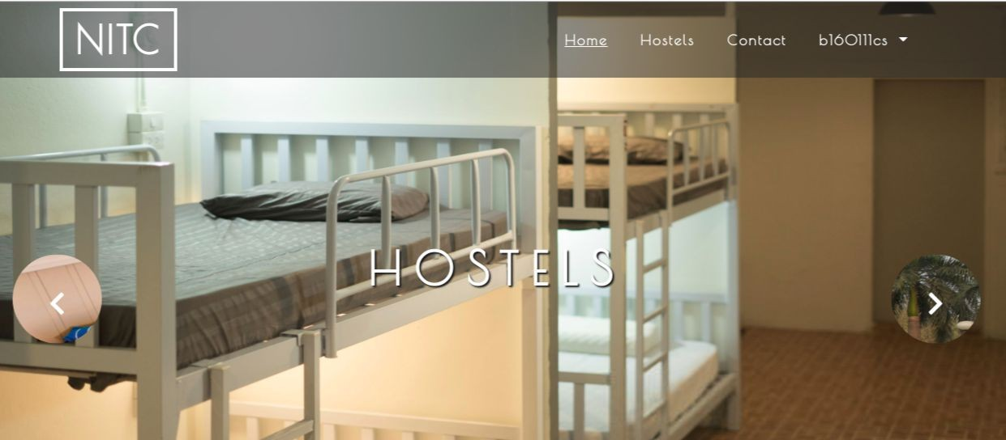

There are 3 different home pages

* 1. User Homepage
  2. Hostel Manager Homepage
  3. Admin Homepage

The homepage basically cointains a navigation bar which takes the user to different pages to perform different activities.

### Hostel Page

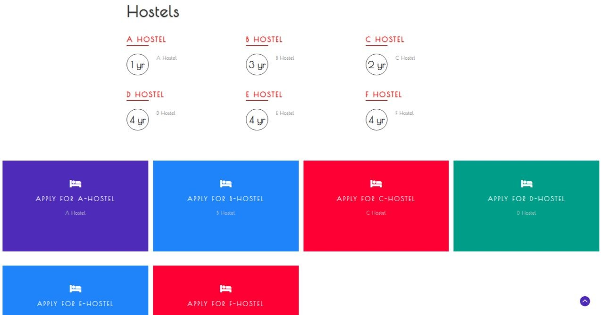

Hostel Page is accessible only to students and they can request for room in any hostel by just clicking on the corresponding hostel link and confirming by entering their password.

### User Profile

This is again of 3 types

* + 1. Student user profile
    2. Hostel manager user profile
    3. Admin user profile

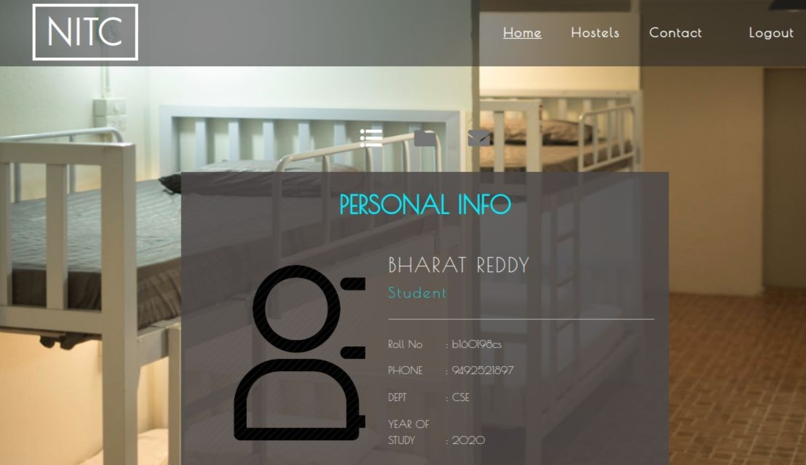

For a student his user profile will also contain the hostel details and hostel manager info if he is allocated a room.

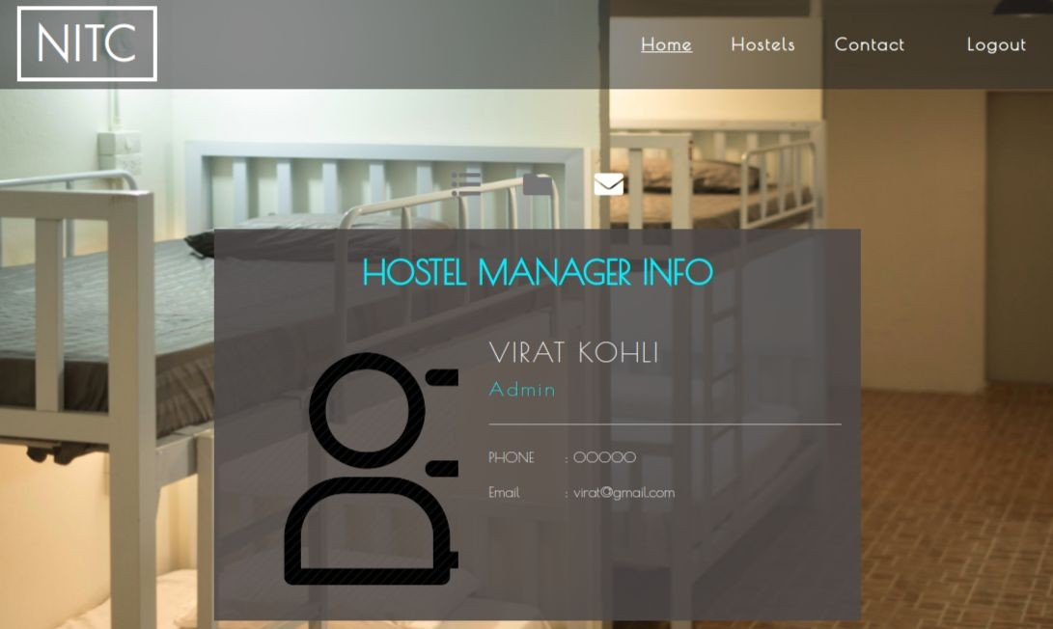

### Applications Received

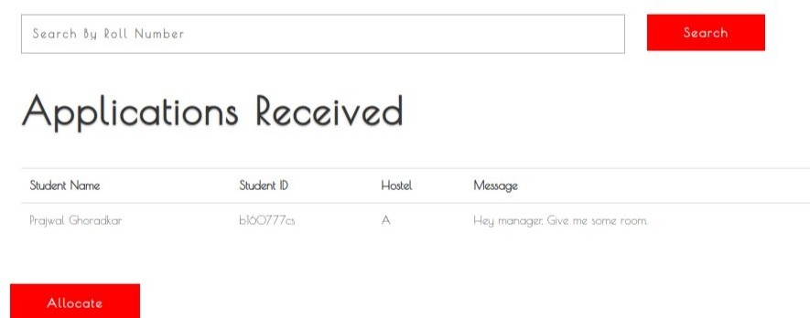

This tab can only be accessed by hostel manager. He can view all the applications his hostel received and allocate rooms accordingly.

### Allocated and Empty Rooms

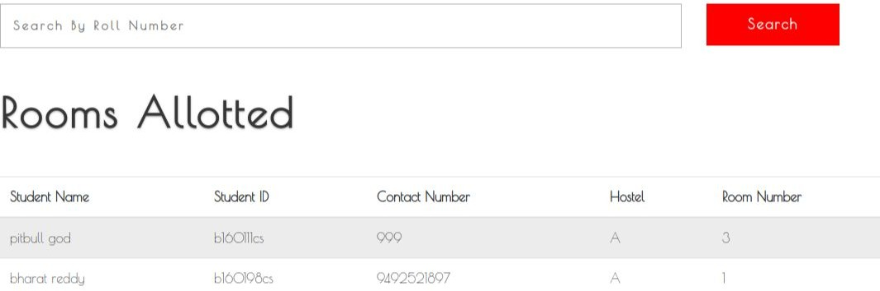

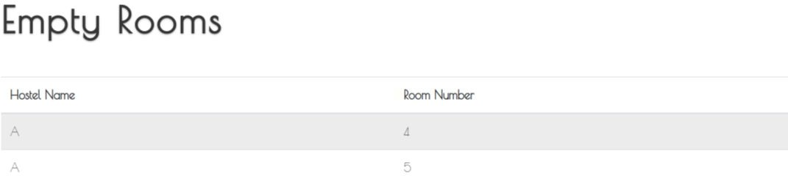

Each hostel manager can look at the list of allocated rooms and empty rooms in his/her hostel by going to this tab.

### Vacate Rooms

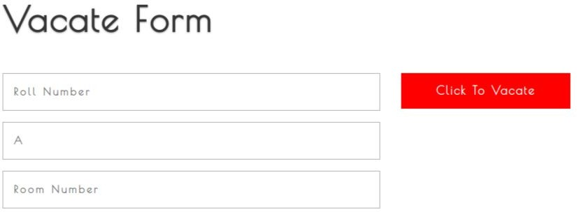

Hostel Manager can vacate an allocated room by filling the student and room details in this form and clicking on “click to vacate” button.

### Appoint/Remove Hostel Manager

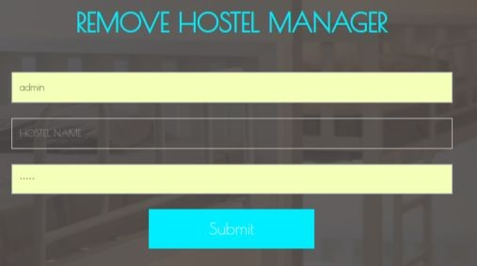

This page can only be accessed by hostel admin. He can allocate a new hostel admin or remove an existing hostel manager.

### Students Page

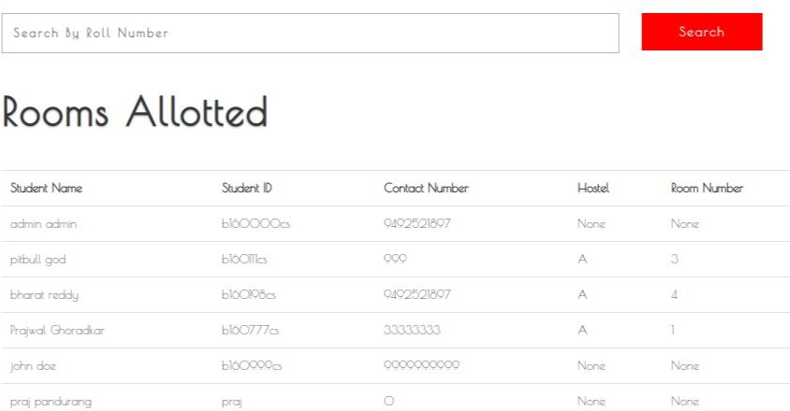

In this page the admin can see list of all the students, their details and the hostel allocated to them along with the room.

### Contact Form

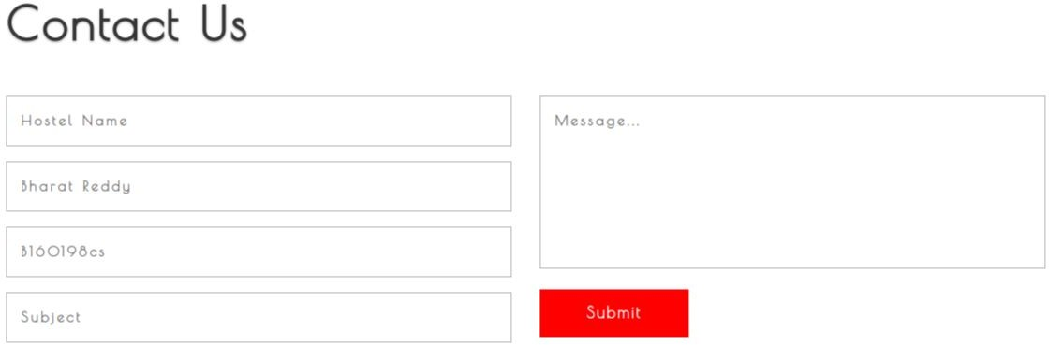

Students can send messages to hostel manager using this form and vice versa.

### Messages Received Page

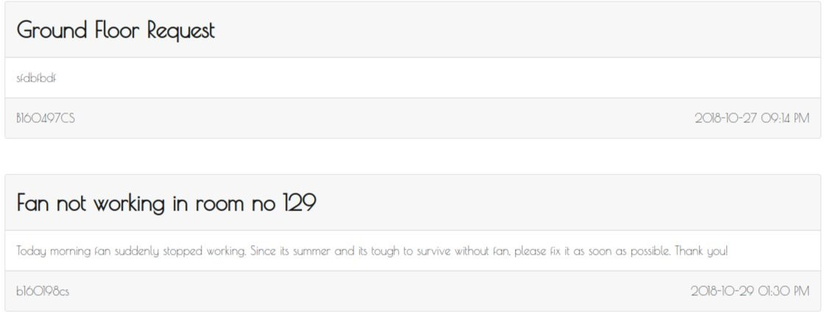

This page cointains messages received by the respective user(either host).